Experiment No. 3: Temperature Sensor Data Reading with Arduino

# Aim

To write code to read temperature and humidity values from the sensor using an Arduino.

# Theory

LM35 Temperature Sensor: The LM35 series are precision integrated-circuit temperature devices with an output voltage linearly proportional to the Centigrade temperature. It provides direct Celsius readings without conversion from Kelvin, offering high accuracy from −55°C to 150°C.

DHT11/DHT22 Sensor: These are digital sensors used for measuring temperature and humidity. DHT22 is more accurate and covers a wider range than DHT11. Both output digital signals readable by an Arduino.

Arduino: Arduino is an open-source microcontroller platform that interfaces with sensors and controls various devices based on sensor inputs.

# Materials Required

- Arduino Uno board  
- DHT11 or DHT22 sensor  
- 10k-ohm resistor (for DHT22)  
- Breadboard  
- Jumper wires  
- USB cable for Arduino  
- Arduino IDE

# Procedure

Step 1: Connect the Sensor

For DHT11:  
- VCC → 5V  
- GND → GND  
- DATA → Pin 2

For DHT22:  
- VCC → 5V  
- GND → GND  
- DATA → Pin 2  
- 10kΩ resistor between VCC and DATA

Step 2: Install DHT Sensor Library

In Arduino IDE, go to Sketch > Include Library > Manage Libraries. Search and install "DHT sensor library" by Adafruit.

Step 3: Write and Upload the Code

Use the provided sketch to read data from the sensor and display it in the Serial Monitor.

Step 4: View Output

Open Serial Monitor (Tools > Serial Monitor) and set baud rate to 9600 to view temperature and humidity values.

## Code

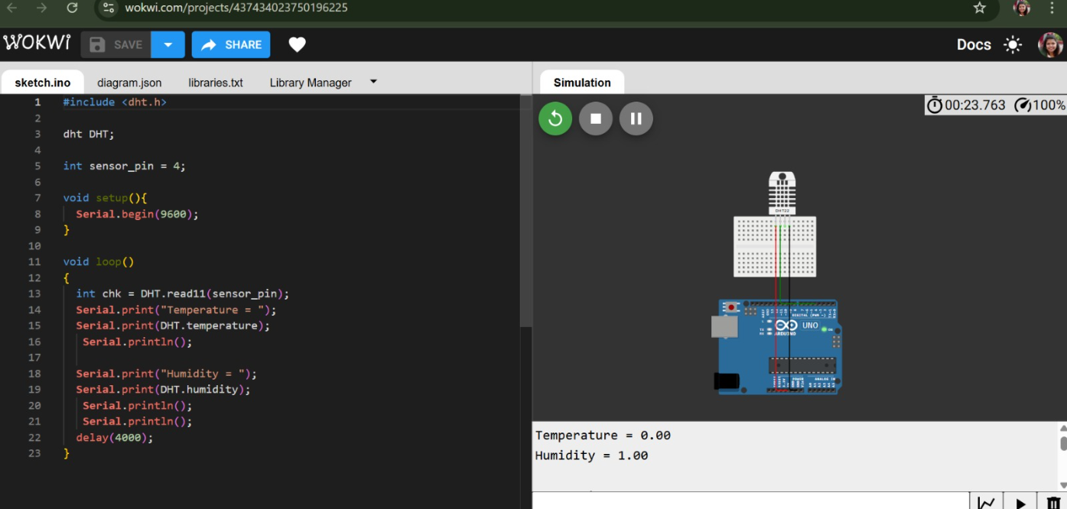

# Working

The sensor measures temperature and humidity and sends it to Arduino as a digital signal. The Arduino reads the data using the DHT library and prints it on the Serial Monitor.

# Conclusion

The lab demonstrated successful interfacing of DHT11/DHT22 with Arduino. Students learned sensor connection, library installation, code uploading, and monitoring real-time data. This strengthens their understanding of sensor integration and data acquisition in IoT.